Live Day 1-Building AI Agents Crash Course

VS Studio
STEP: Initialize uv to start a virtual env for executing python commands

> uv init
If not installed,
> brew install uv (MacOS)
> uv –version # if installed, expect number

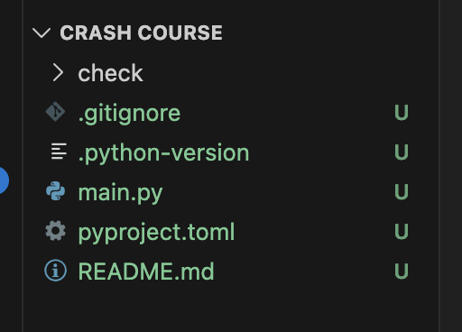

STEP: Check if python exists and then setup virtual environment

> uv python list

STEP: Install latest version inside the project folder
> uv python pin 3.13

STEP: Create python in the virtual ‘env’ environment
> uv venv env --python 3.12. # here we specify ‘env’ in command line so it can create it (view in explorer on the left as env gets created>

STEP: For dev work – first create the virtual environment and then activate it
-- activate using conda, python, uv –> here we are using uv

STEP: Now activate the env
> source env/bin/activate

STEP: Now, to not push the file into the github.. put the env in the gitignore file

STEP: Click .gitignore
Add the files env, .env in that within the virtual environments list
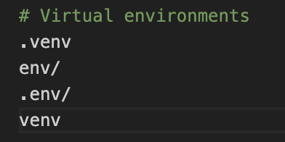

NOTE: In the .env file we will keep the API keys

STEP: Just create another requirements.txt file too

Appendix
Basic git commands
- cls – clear screen
- mkdir
- ls
- cd
- cd..
- cd\

